**CMPG313 – Theory Assignment 2 – 16 March 2024**

**Question 1 (Campus Navigation)**

Formulate a search problem for a new student who needs to find the quickest route from the main entrance to the various departments on campus. [6]

**Question 2 (Event Planning)**

Devise a search problem for planning and scheduling campus events in a semester without conflicts. [6]

**Question 3 (Library Book Retrieval)**

Formulate a search problem for finding and retrieving a set of books from different sections of the university library. [6]

**Question 4 (Solving Problems by Searching)**

Consider the next search problem with start state S and goal state G. The action costs are on the branches (edges), and the heuristic values are next to the state names.

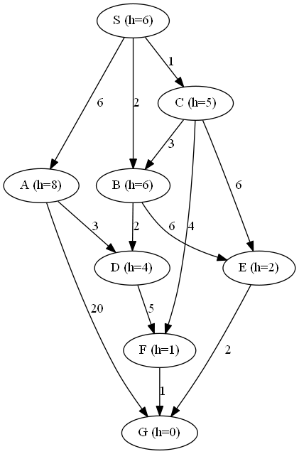

Perform a uniform-cost search and show all the iterations and steps clearly. [20]

Total: [38]